

ITA1416-ETHICAL HACKING
SLOT B
Dr. K RAMESH KUMAR
PRESENTED BY:
SURU SAI KEERTHI [192424368]

1.Get-ComputerInfo
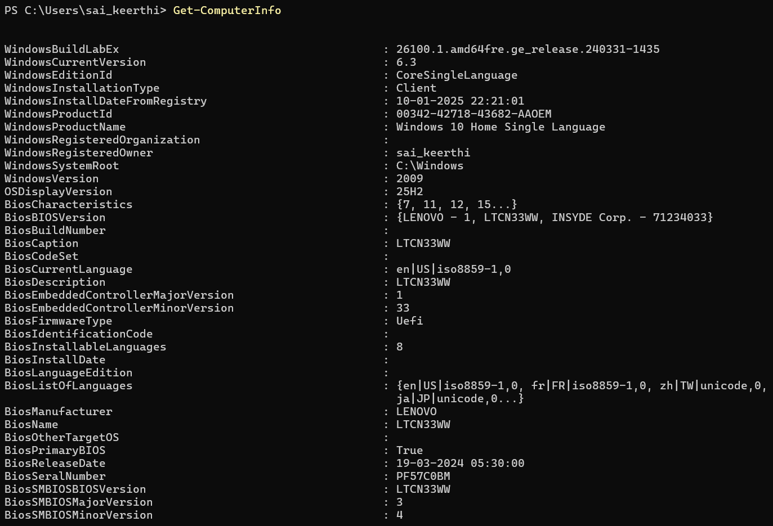

2. Get-CimInstance Win32_OperatingSystem
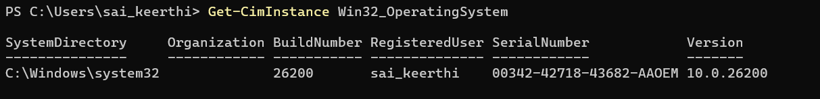

3. Get-CimInstance Win32_Processor

4. Get-CimInstance Win32_BIOS
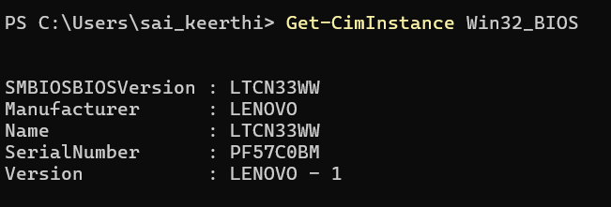

5. Get-Disk

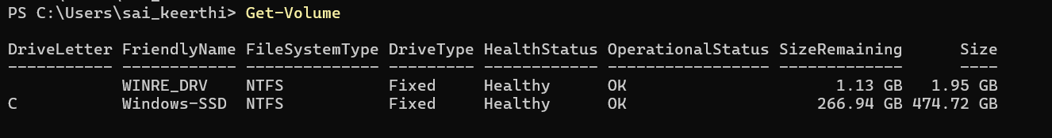
6. Get-Volume

7. Get-NetIPAddress
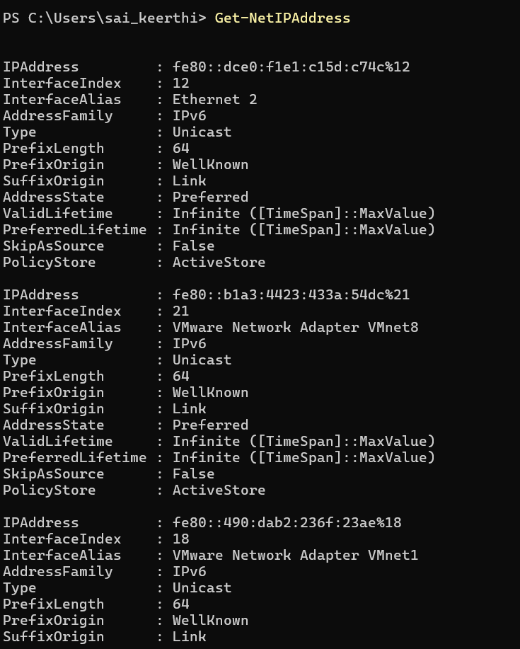

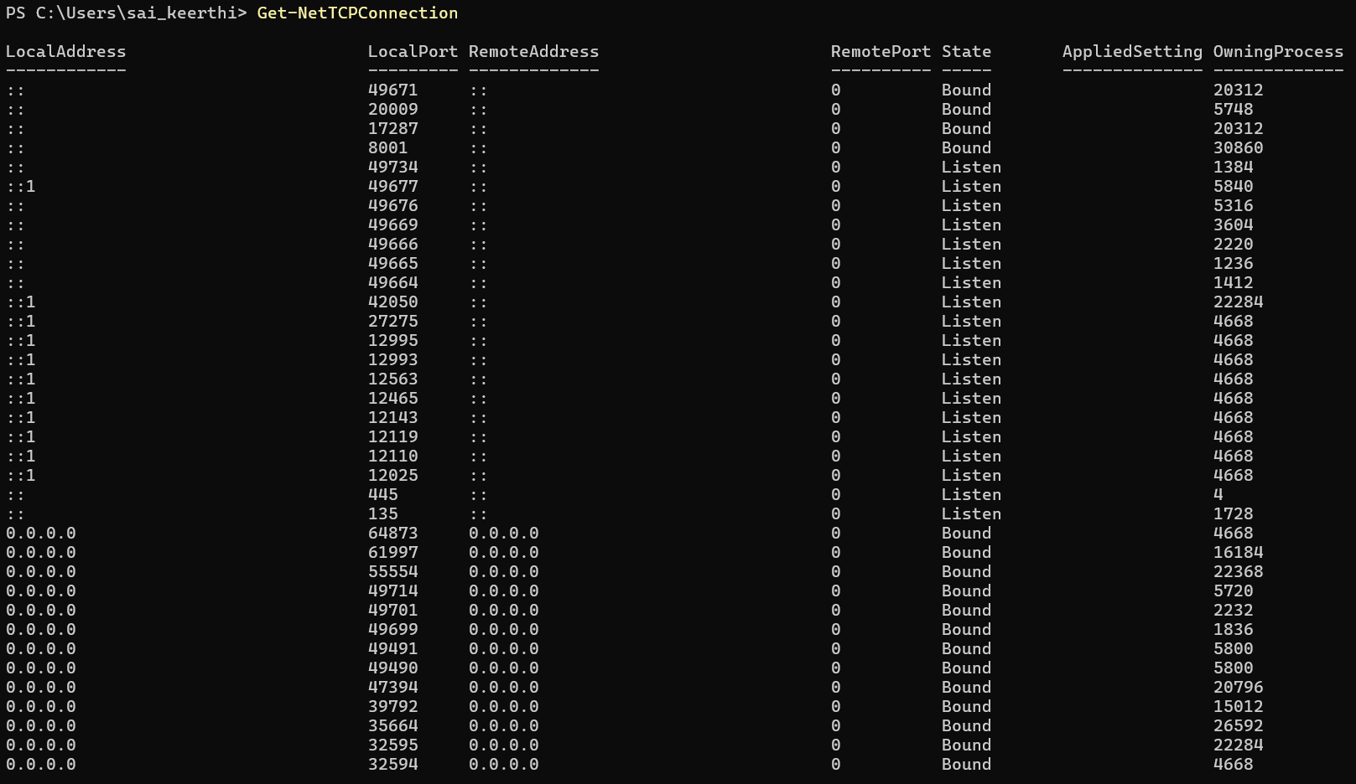
8. Get-NetTCPConnection

9. Get-NetAdapter
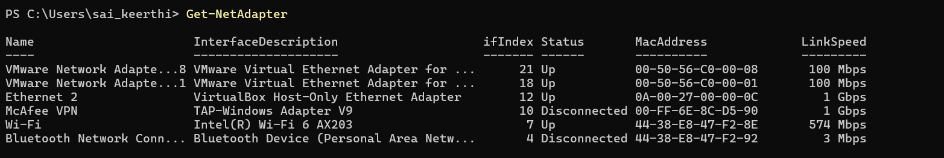

10. Get-Process

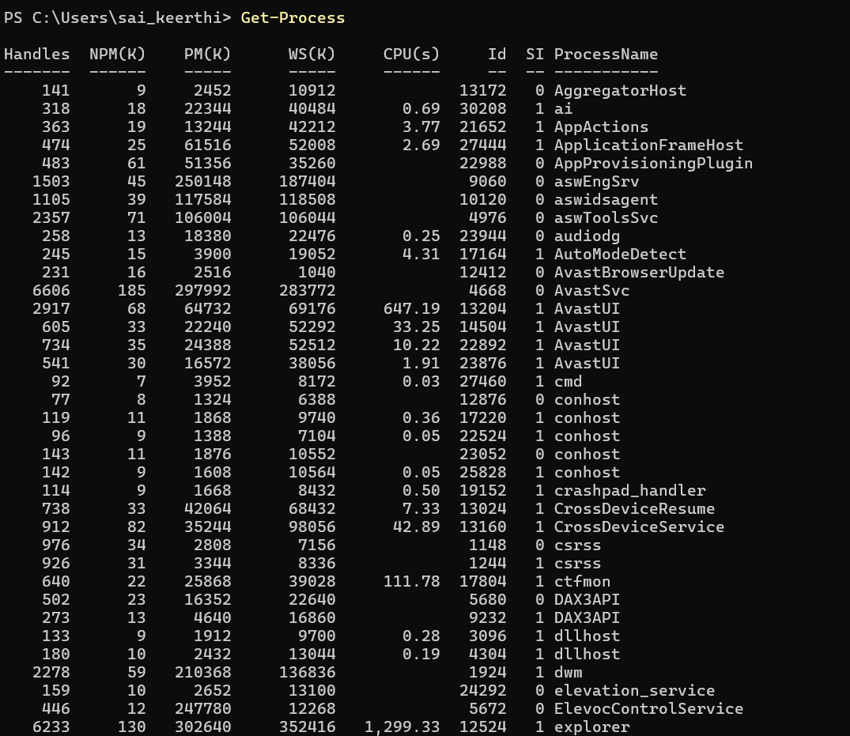

11. Get-Service
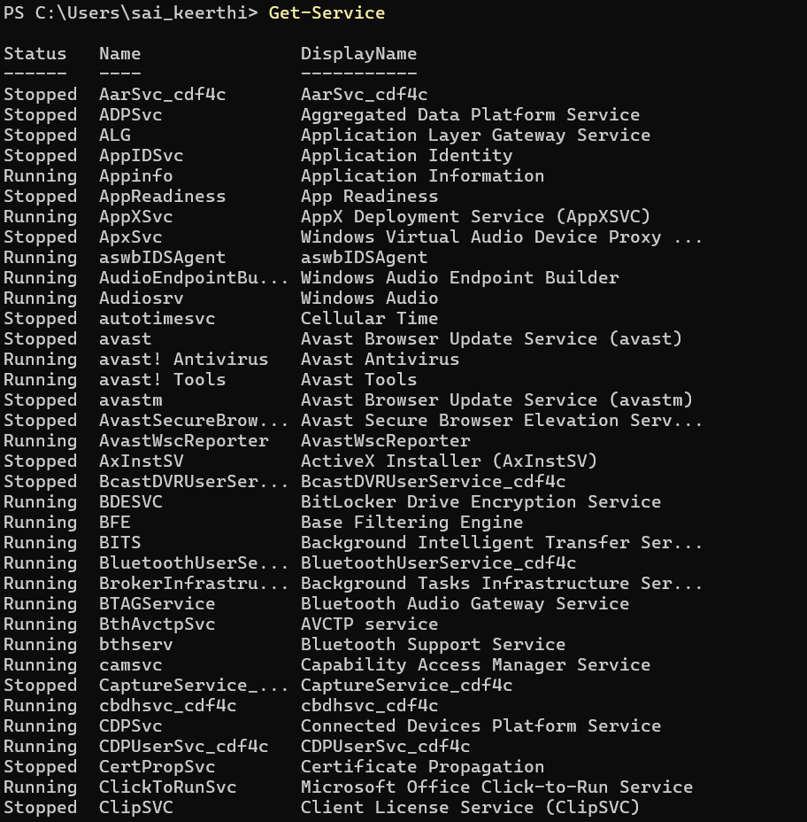

12. Get-LocalUser
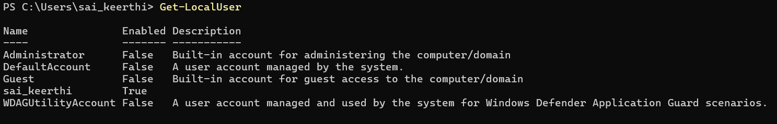

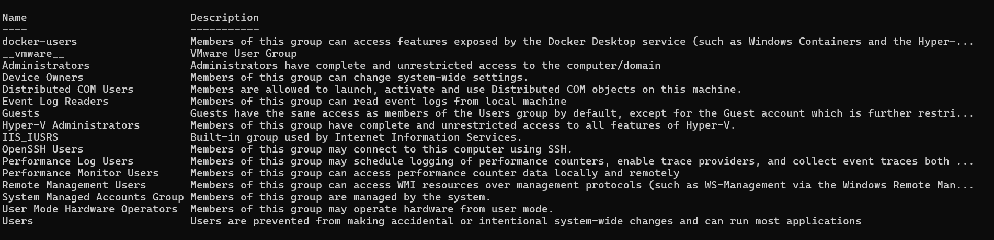
13. Get-LocalGroup

14. Get-HotFix
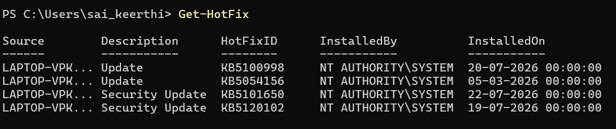

15. Get-ScheduledTask
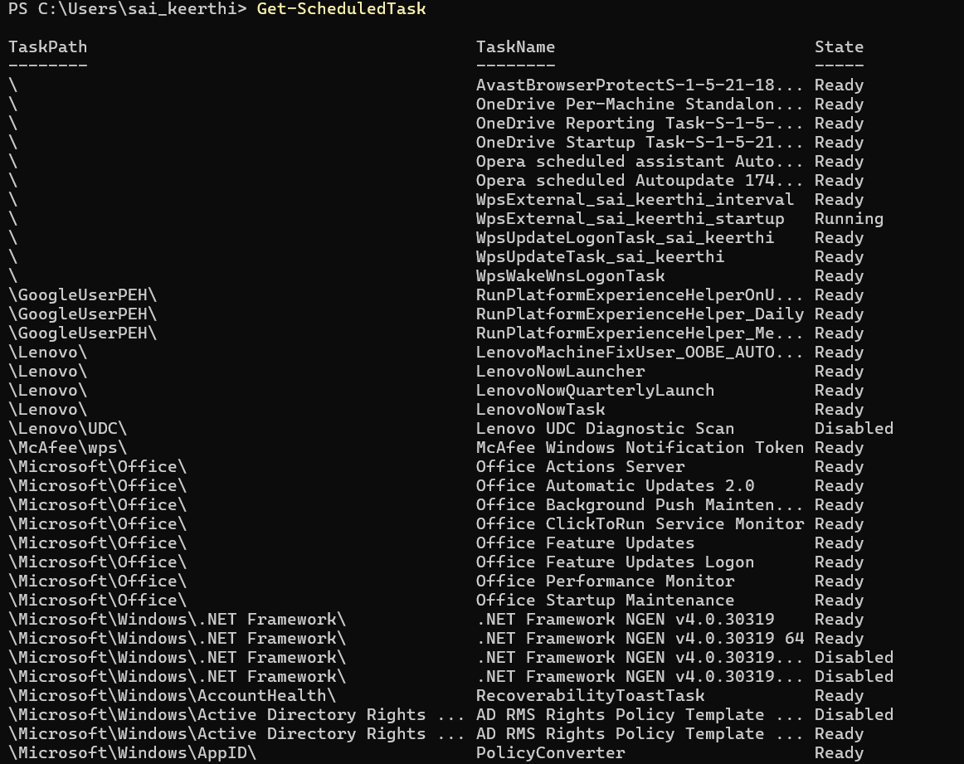

16. Get-MpComputerStatus
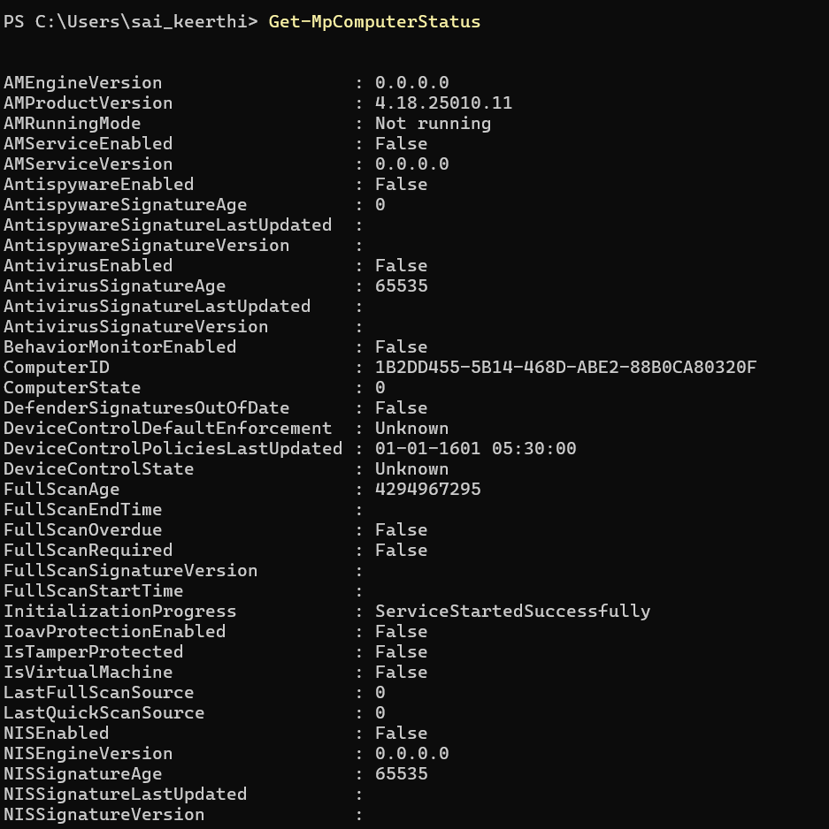

17. Get-NetFirewallProfile
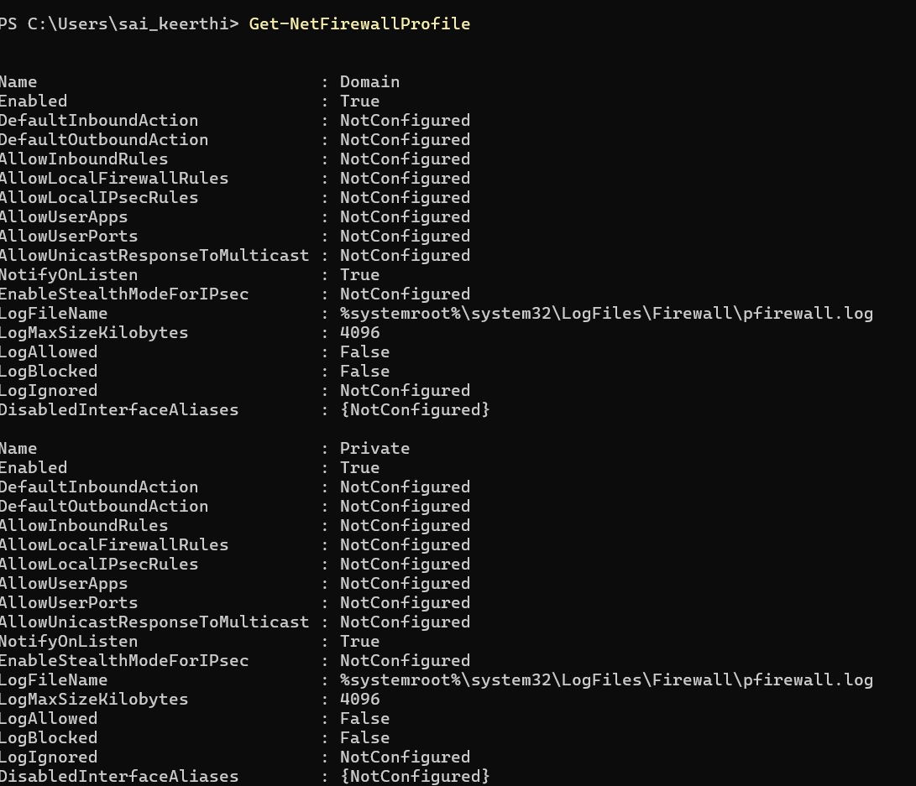

18. Get-ChildItem Env:
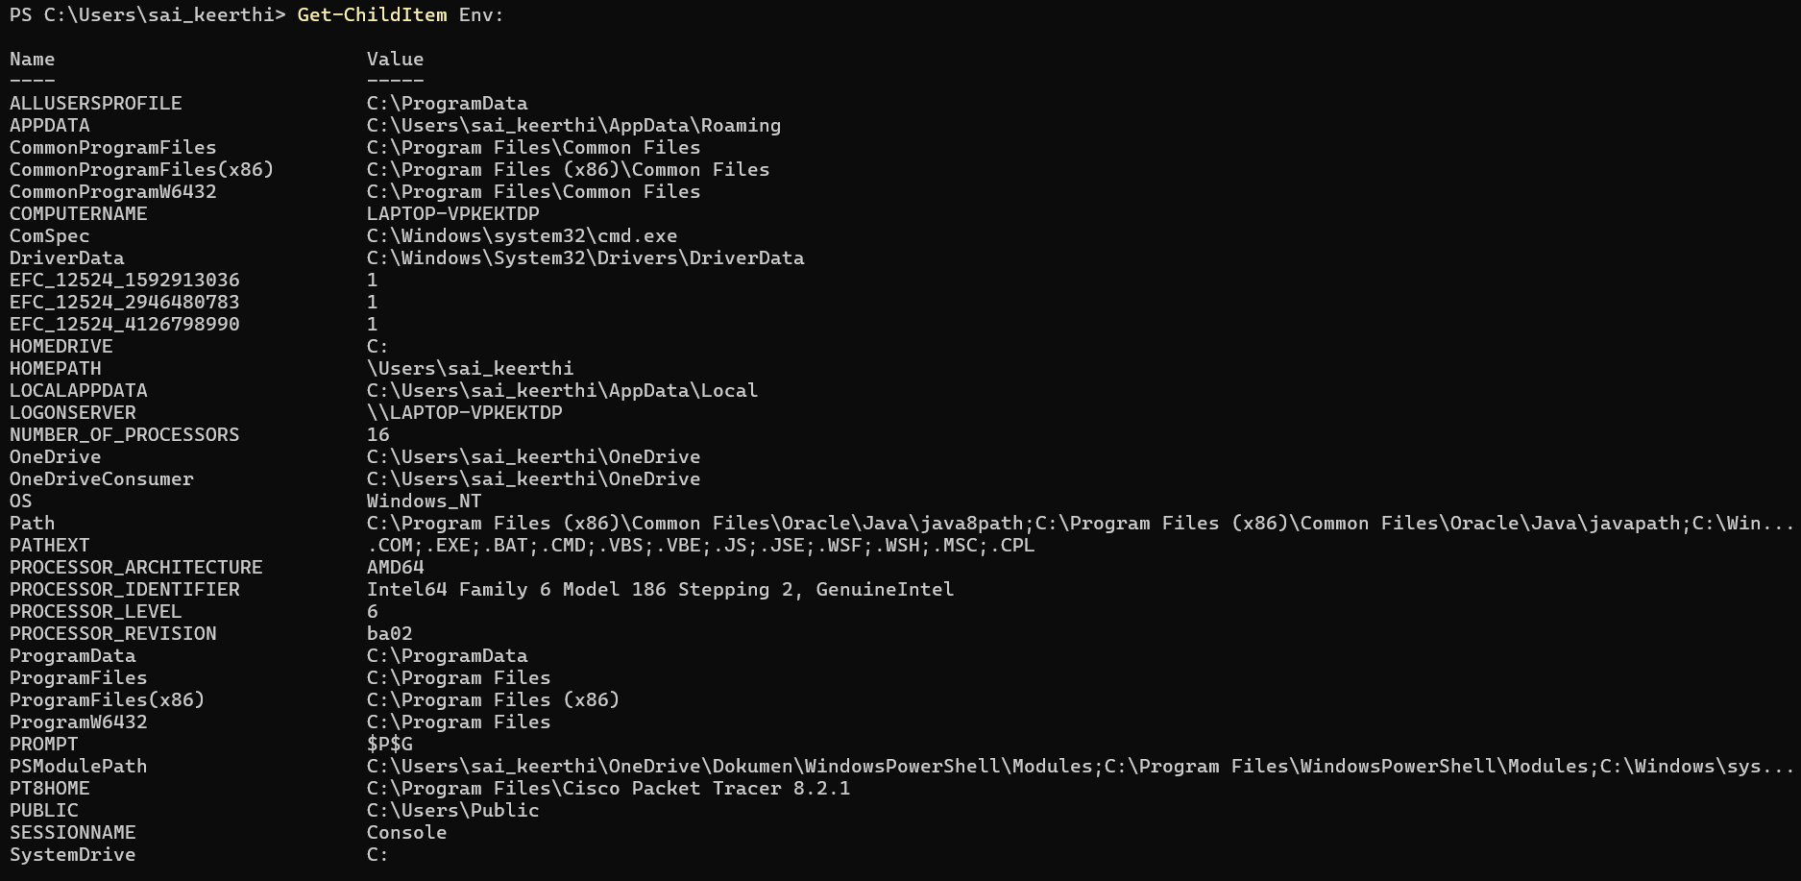
19. Get-WinEvent -LogName Security
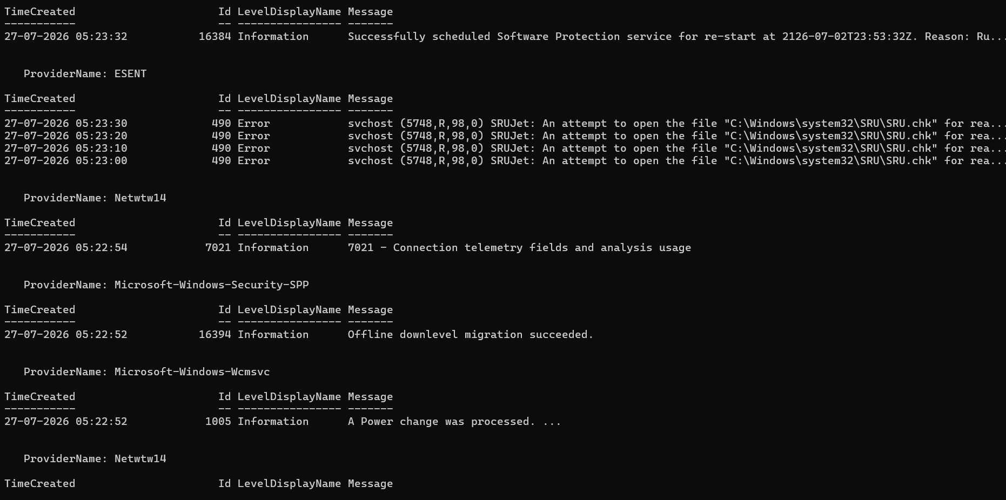
20. $PSVersionTable
